Work - 03
CLASS 09 - SCIENCE

 | Section A
1 | Assertion (A): The qualityof sound enables us to distinguish one sound from another having the same pitch and loudness. Reason (R): The sound which is more pleasant is said to be of a lowquality.  a) Both A and R are true and R is the correct explanation of A.  b) Both A and R are true but R is not the correct explanation of A.  c) A is true but R is false.  d) A is false but R is true. | [1]
2 | Assertion (A): Sound would travel faster on a hot summer day than on a cold winter day. Reason (R): Velocity of sound is directly proportional to the square of its absolute temperature.  a) Both A and R are true and R is the correct explanation of A.  b) Both A and R are true but R is not the correct explanation of A.  c) A is true but R is false.  d) A is false but R is true. | [1]
3 | Assertion (A): The amplitude of a wave is the same as the amplitude of the vibrating body producing the wave. Reason (R): The loudness or softness of a sound is determinedby its amplitude.  a) Both A and R are true and R is the correct explanation of A.  b) Both A and R are true but R is not the correct explanation of A.  c) A is true but R is false.  d) A is false but R is true. | [1]
4 | Assertion (A): The velocity of sound in hydrogen gas is less than the velocity of sound in oxygen gas. Reason (R): The density of oxygen is more than the density of hydrogen.  a) Both A and R are true and R is the correct explanation of A.  b) Both A and R are true but R is not the correct explanation of A.  c) A is true but R is false.  d) A is false but R is true. | [1]
5 | Assertion (A): Supersonic speed exceeds the speed of sound. Reason (R): Bullets, jet aircraft, etc. often travel at supersonic speeds.  a) Both A and R are true and R is the correct explanation of A.  b) Both A and R are true but R is not the correct explanation of A.  c) A is true but R is false.  d) A is false but R is true. | [1]
6 | Assertion (A): The longitudinal waves are called pressure waves. Reason (R): Propagation of longitudinal waves through a medium involves changes in pressure and volume of air, when compression and rarefaction are formed.  a) Both A and R are true and R is the correct explanation of A.  b) Both A and R are true but R is not the correct explanation of A.  c) A is true but R is false.  d) A is false but R is true. | [1]
7 | Assertion (A): Echo is produced when sound is incident on hard and polished surface. Reason (R): Sound energy can be totally reflected by objects with soft and loose texture.  a) Both A and R are true and R is the correct explanation of A.  b) Both A and R are true but R is not the correct explanation of A.  c) A is true but R is false.  d) A is false but R is true. | [1]
8 | Assertion (A): Waves produced by a motorboat sailing in water are both longitudinal and transverse in nature. Reason (B): The longitudinal and transverse waves cannot be produced simultaneously.  a) Both A and R are true and R is the correct explanation of A.  b) Both A and R are true but R is not the correct explanation of A.  c) A is true but R is false.  d) A is false but R is true. | [1]
9 | Assertion (A): The flash of lightning is seen before the sound of thunder is heard. Reason (R): Speed of sound is greater than speed of light.  a) Both A and R are true and R is the correct explanation of A.  b) Both A and R are true but R is not the correct explanation of A.  c) A is true but R is false.  d) A is false but R is true. | [1]
10 | Assertion (A): Pitch is the physiological sensation that helps in distinguishing a shrill sound from a flat sound. Reason (R): The faster the vibration of the source, the higher is the frequency and the higher is the pitch.  a) Both A and R are true and R is the correct explanation of A.  b) Both A and R are true but R is not the correct explanation of A.  c) A is true but R is false.  d) A is false but R is true. | [1]
11 | Assertion (A): A vibrating tuning fork sounds louder when its stem is pressed against a desktop. Reason (R): When a wave reaches another denser medium, part of the wave is reflected.  a) Both A and R are true and R is the correct explanation of A.  b) Both A and R are true but R is not the correct explanation of A.  c) A is true but R is false.  d) A is false but R is true. | [1]
12 | Assertion (A): Compression and rarefaction involve changes in density and pressure. Reason (R): When particles are compressed, the density of medium increases and when they are rarefied, the density of medium decreases.  a) Both A and R are true and R is the correct explanation of A.  b) Both A and R are true but R is not the correct explanation of A.  c) A is true but R is false.  d) A is false but R is true. | [1]
13 | Assertion (A): The velocity of sound changes as we go up in the atmosphere. Reason (R): Pressure decreases as we go up in the atmosphere.  a) Both A and R are true and R is the correct explanation of A.  b) Both A and R are true but R is not the correct explanation of A.  c) A is true but R is false.  d) A is false but R is true. | [1]
14 | Assertion (A): Transverse waves travel through air in an organ pipe. Reason (R): Air possesses only volume elasticity.  a) Both A and R are true and R is the correct explanation of A.  b) Both A and R are true but R is not the correct explanation of A.  c) A is true but R is false.  d) A is false but R is true. | [1]
15 | Assertion (A): The speed of sound tells us the rate at which the sound travels from the sound - producing body to our ears. Reason (R): The speed of sound depends on the temperature.  a) Both A and R are true and R is the correct explanation of A.  b) Both A and R are true but R is not the correct explanation of A.  c) A is true but R is false.  d) A is false but R is true. | [1]
16 | Assertion (A): Waves produced in a cylinder containing a liquid by moving its piston back and forth are longitudinal waves. Reason (R): In longitudinal waves, the particles of the medium oscillate parallel to the direction of propagation of the wave.  a) Both A and R are true and R is the correct explanation of A.  b) Both A and R are true but R is not the correct explanation of A.  c) A is true but R is false.  d) A is false but R is true. | [1]
17 | Assertion (A): If we stand in one corner of a big empty hall and shout the word hello we will hear the word hello coming from the empty hall. Reason (R): The sound of our hello is reflected from the walls of the hall and this reflected sound forms the echo.  a) Both A and R are true and R is the correct explanation of A.  b) Both A and R are true but R is not the correct explanation of A.  c) A is true but R is false.  d) A is false but R is true. | [1]
18 | Assertion (A): The velocity of sound increases with increase in humidity. Reason (R): Velocity of sound does not depend upon the medium.  a) Both A and R are true and R is the correct explanation of A.  b) Both A and R are true but R is not the correct explanation of A.  c) A is true but R is false.  d) A is false but R is true. | [1]
19 | Assertion (A): The speed of sound in solids is maximum though their density is large. Reason (R): The coefficient of elasticity of solid is large.  a) Both A and R are true and R is the correct explanation of A.  b) Both A and R are true but R is not the correct explanation of A.  c) A is true but R is false.  d) A is false but R is true. | [1]
20 | Assertion (A): Two persons on the surface of moon cannot talk to each other. Reason (R): There is no atmosphere on moon.  a) Both A and R are true and R is the correct explanation of A.  b) Both A and R are true but R is not the correct explanation of A.  c) A is true but R is false.  d) A is false but R is true. | [1]
21 | Assertion (A): Sound needs a material mediumfor their propagation. Reason (R): Sound waves are mechanical waves.  a) Both A and R are true and R is the correct explanation of A.  b) Both A and R are true but R is not the correct explanation of A.  c) A is true but R is false.  d) A is false but R is true. | [1]
22 | Assertion (A): Sound is produced when an object vibrates or moves back and forth rapidly. Reason (R): The energy required to make an object vibrateis provided by some outside source.  a) Both A and R are true and R is the correct explanation of A.  b) Both A and R are true but R is not the correct explanation of A.  c) A is true but R is false.  d) A is false but R is true. | [1]
23 | Assertion (A): Transverse waves can be produced in liquids. Reason (R): Light waves are transverse waves.  a) Both A and R are true and R is the correct explanation of A.  b) Both A and R are true but R is not the correct explanation of A.  c) A is true but R is false.  d) A is false but R is true. | [1]
24 | Assertion (A): A soundis a form of energy that travels in the form of waves. Reason (R): The disturbance which moves through amedium when the particles of the medium set the neighbouring particles into motion is known as a wave.  a) Both A and R are true and R is the correct explanation of A.  b) Both A and R are true but R is not the correct explanation of A.  c) A is true but R is false.  d) A is false but R is true. | [1]
 | Section B
25 | A pulse was created in a slinky/string of length 4 m by a group of students. They observed that it returned, after reflection, at the point of creation 6 times in 10 seconds and calculated the speed as follows:   The correct speed was calculated by the student:  a) B  b) D  c) A  d) C | [1]
 | Section C
26 | In Young’s double - slit experiment, the two slits act as coherent sources of equal amplitude a and of wavelength$λ$ . In another experiment with the same setup, the two slits are sources of equal amplitude a and wavelength $λ$ , but are incoherent. The ratio of intensities of light at the midpoint of the screen in the first case to that in the second case is  a) 4 : 3  b) 1 : 2  c) 2 : 1  d) 3 : 4 | [1]
 | Section D
27 | If a freely suspended vertical spring is pulled in downward direction and then released, which type of waves are produced in the spring? | [1]
28 | What is the audible range of the average human ear? | [1]
29 | What is sound and how is it produced? | [1]
30 | What are mechanical waves? | [1]
31 | What do you mean by a wave? | [1]
32 | Why is sound wave called a longitudinal wave? | [1]
33 | In which of the three media, air, water or iron, does sound travel the fastest at a particular temperature? | [1]
34 | In the experiment on studying the laws of reflection of sound, the tube facing the clock is placed as shown. The position of the second tube, at which the ear will get the best reflected sound, is obtained when θequals: 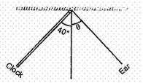 | [1]
35 | An echo is heard in 3 s. What is the distance of the reflecting surface from the source, given that the speed of sound is 342 m s$​^{−1}$ ? | [1]
36 | What kind of waves are produced in an earthquake before the main shock wave begins? | [1]
37 | What do you understand by low pitched and high pitched sound? | [1]
38 | What is the range of frequencies associated with  - Infrasound?  - Ultrasound? | [1]
39 | Which characteristic of the sound helps you to identify your friend by his voice while sitting with others in a dark room? | [1]
40 | Calculate the wavelength of a sound wave whose frequency is 220 Hz and speed is 440 m/s in a given medium. | [1]
41 | What is intensity of sound? | [1]
42 | Which of the two graphs (a) and (b) (Fig.)representing the human voice is likely to be the male voice? Give reason for your answer. 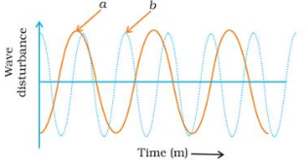 | [1]
43 | Among air, water and steel, in which medium, the sound wave will travel faster? | [1]
44 | A person clapped his hands near a cliff and heard the echo after 2s. What is the distance of the cliff from the person if the speed of the sound, v is taken as 346 ms$​^{−1}$ ? | [1]
45 | The sound produced by a thunderstorm is heard 10 s after the lightning is seen. Calculate the approximate distance of the thunder cloud. (Given the speed of sound = 340 ms$​^{–1}$ ) | [1]
46 | Why can’t we hear the sound of an explosion on the surface of the Moon? | [1]
47 | What is one complete oscillation? | [1]
48 | Why are roofs and walls of an auditorium/hall generally covered with sound absorbent materials? | [1]
49 | If any explosion takes place at the bottom of a lake, what type of shock waves in water will take place? | [1]
50 | Guess which sound has a higher pitch: guitar or car horn? | [1]
51 | A stone is thrown in a pond. 12 Full ripples are produced in 1 second. If the distance between a crest and a trough is 10 cm, calculate the wavelength and velocity of the wave. | [1]
52 | Kunal and Abhimanyu were waiting to go across a railway crossing. Kunal jumped over the barrier and curiously put his ear on the railway track. Abhimanyu opposed Kunal and pulled him away from the railway track.  - Why did Kunal put his ear on the railway track?  - Can sound travel faster through (i) copper (ii) water?  - Why did Abhimanyu pull Kunal away from the railway track? | [3]
53 | Reena’s grandmother took her mother to a doctor as she was four months pregnant for ultrasonography. But she showed her interest in determining whether the child is a boy or a girl. The doctor was annoyed and refused to disclose the gender of the child.  - What is ultrasonography?  - On what principle does it work?  - Why do you think the doctor refused to determine the gender of the child?  - What values are promoted by the doctor? | [3]
54 | Flash and thunder are produced simultaneously. But thunder is heard a few seconds after the flash is seen, why? | [3]
55 | Observe the given figure and answer the following questions: 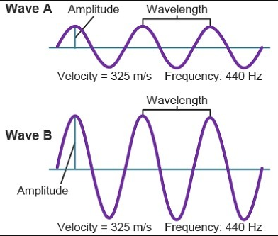  - Identify the characteristics of the two graphs as shown above in the given figure.  - What is the relationship between the velocity of sound, its wavelength, and frequency?  - What is the term for the magnitude of the maximum disturbance in the medium on either side of the mean value?  - Give the unit of frequency? | [3]
56 | Kanika carried out an experiment on determination of speed of sound in air using resonance tube apparatus and obtained absurd results. She should  - record the result as such.  - manipulate the result and report the answer nearer to actual value of velocity of sound in air.  - copy the result obtained by another student.  - report the result as such and discuss the matter with the teacher to find out the reasons for wrong results.  Answer the following questions based on the above information:  - Which is the most appropriate option for Kanika?  - What values will Kanika be promoting through preferring this option?  - Give one more example of promoting such values in real life situations. | [3]
57 | Observe the following graphical diagram and answer the following questions: 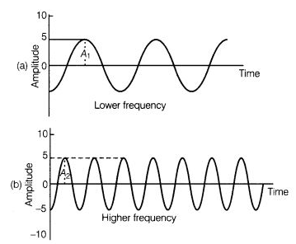  - What is represented by the graphical diagram shown above?  - Which wave characteristic determine the pitch of sound?  - What is the relationship between pitch and frequency? | [3]
58 | Study the given below diagram and answer the following questions: 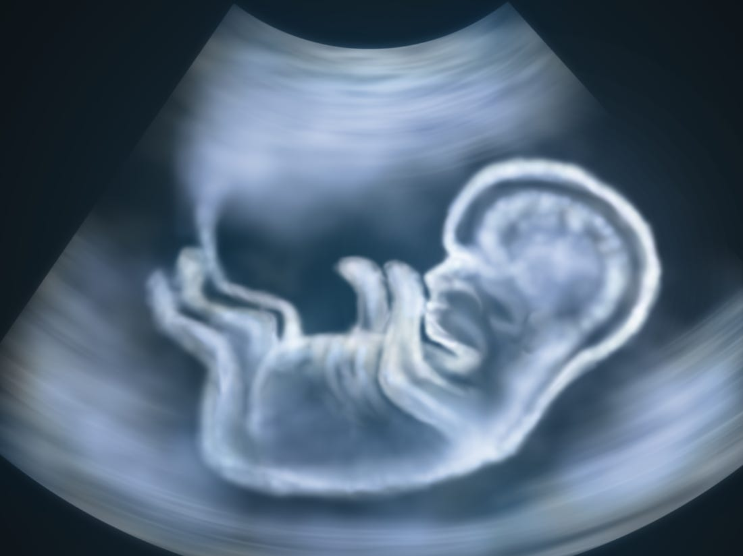  - Identify the application of ultrasound in the above diagram.  - Explain the working principle of this medical procedure.  - What is the range of frequencies associated with ultrasound? | [3]
59 | Two children are at opposite ends of an aluminium rod. One strikes the end of the rod with a stone. Find the ratio of times taken by the sound wave in air and in aluminium to reach the second child. | [3]
60 | Observe the following diagram and answer the following questions: 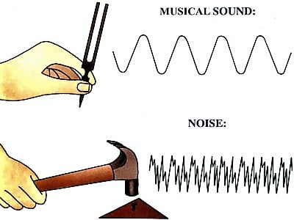  - What is the difference between longitudinal and transverse wave?  - Mention the three characteristics of sound.  - What is the crest and trough? | [3]
61 | - Sound is produced when your school bell is struck with a hammer. Why?  - A powerful sound signal sent from a ship is received again after 4.8 seconds. How deep is the ocean bottom? (Speed of sound in water = 1500 m/s). | [5]
62 | - What is meant by reflection of sound?  - Describe an activity to study the reflection of sound.  - State the laws of reflection of sound. | [5]
63 | Define frequency and wavelength with reference to sound. Explain, what is echo? Write full form of SONAR. Give two applications of ultrasound. | [5]
64 | - What is meant by frequency of sound waves?  - Give the range of frequencies of sound waves that an average human ear can detect.  - A source of wave produces 20 crests and 20 troughs in 0.2 s. The distance between a crest and next trough is 50 cm. Find the  - wavelength  - frequency  - time period of the wave. | [5]
65 | Represent graphically by two separate diagrams in each case  - Two sound waves having the same amplitude but different frequencies?  - Two sound waves having the same frequency but different amplitudes.  - Two sound waves having different amplitudes and also different wavelengths. | [5]
66 | - Which characteristic of sound helps to identify your friend by his voice while sitting with others in a dark room?  - State the relationship between frequency and time period of a wave. The wavelength of vibrations produced on the surface of the water is 4 cm. If the wave velocity is 20 m/s find the frequency and Time period. | [5]
67 | - How will you determine the depth of a sea using echo ranging in SONAR method?  - A SONAR device on a submarine sends out a signal and receives an echo 5s later. Calculate the speed of sound in water if the distance of the object from the submarine in 2625 m. | [5]
68 | - On which factors the speed of sound depends?  - How bat searches its prey at night? | [5]
69 | Explain the working and application of a sonar. | [5]
70 | - What is echo ranging? State any one application of this technique.  - The wavelength of waves produced on the surface of the water is 20 cm. If the wave velocity is 36 m/s.Calculate  - The number of waves produced in one second.  - The time required to produceone wave? | [5]
71 | Draw a curve showing density or pressure variations with respect to distance for a disturbance produced by sound. Mark the position of compression and rarefaction on this curve. Also, define wavelengths and time period using this curve. | [5]
72 | - What is the difference between echo and reverberation?  - How can we reducereverberation in anauditorium or a big hall?  - Which materials are good absorbers of sound?  - Why we can hear more clearly in a room having curtains? | [5]
73 | How do stethoscope and megaphone work on the principle of multiple reflections of sound? | [5]
74 | A person standing between two vertical cliffs and 640 m away from the nearest cliff shouted. He heard the first echo after 4 seconds and the second echo 3 seconds later. Calculate  - the velocity of sound in air, and  - the distance between the cliffs. | [5]

